 |  |  |  | USI, Human resource unit
Largo Bernasconi 2
6850 Mendrisio
Svizzera
 |  |  |  | Usi, Human resource unit
da  tel  e-mail  web  data |  | + | Human resource unit  41 58 666 5859  personale.lu@usi.ch  10.09.2025 | Usi, Human resource unit
dasdasdsas
Payment order for

Name and last name (mandatory)
Date of birth (mandatory)
Complete address
E-mail (mandatory)

Faculty
Institute / Service
Project
Activity
Activity carried out | - At USI Mendrisio  - Form abroad (where)?

Date / Period | Activity descripton | Currency | Amount
Totale |  | CHF
 |  | EUR
 |  | Other currency

Authorization from the professor in charge/institute director/project leader.

Date |  | Professor signature
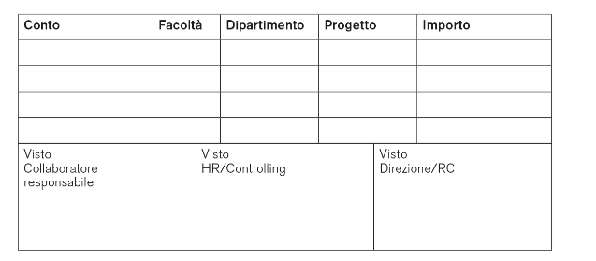 |  | Signature of the fee recipient

Applied Swiss income tax deduction

15 % | Daily income up to CHF 200.-
20 % | Daily income from CHF 201.- a 1’000.-
25 % | Daily income from CHF 1001.- a 3’000.-
30 % | Daily income over CHF 3’001.-

Incomplete forms will be returned to sender
Expenses must be documented with the relevant original receipts (only credit card payment receipt or bank statement is not sufficient), copies or scanned versions of receipts are not accepted

